November 2, 2017
Designing the Scientific “Paper” of the Future
Organized by: Rebecca Ross, Canadian Science Publishing
Speakers: Steven Cooke, Professor, Canada Research Chair at Carleton University; Maria DeRosa, Professor, Chemistry Department at Carleton University; Brian Owens, Freelance writer and journalist, Nature, New Scientist, Science, and the Canadian Medical Association Journal; Chelsea Rochman, Assistant Professor, Department of Ecology and Evolutionary Biology at the University of Toronto, Laura Coristine, Scientist, Conservation Biologist and Liber Ero Postdoctoral Fellow, University of British Columbia
Moderator: Laura Coristine, Scientist, Conservation Biologist and Liber Ero Postdoctoral Fellow, University of British Columbia
Figure credit is to: Liisa Sorsa, Thinklink Graphics
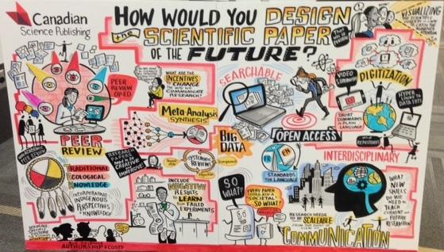
Takeaways and recommendations
Engaging with a non-scientific audience
- More publicly funded science is migrating to open access journals, but that doesn’t ensure it will be widely read or understood. How can we make our papers more accessible?
- Prioritizing vetted science and protecting and instilling trust in scholarly research is more important than ever in a world where fake news and predatory publishing practices contribute to a public that does not always trust evidence or scientists.
- Science increasingly addresses time-sensitive issues (climate change, technological advances, etc). Information around this research needs to be communicated in a variety of ways (e.g. op-ed columns, media interviews, blog posts, policy briefings, presentations to government committees as well as the more traditional academic publication) in order to inform a variety of audiences ranging from policy-makers to general public and scientists.
- More funding is needed for systematic reviews as policymakers don’t have time to read an entire body of knowledge (i.e., numerous individual scientific papers).
- The most important information is often found in the methods, results and figures sections of a scientific paper, but they are usually the hardest parts for a lay person to understand. Can they be presented in a more accessible way? “Science literacy has to be appreciation for science as well as the scientific method.”
- Write scientific papers in an active, not passive, voice.
Where are the incentives to change?
- What is the researcher’s incentive to communicate their results in different ways?
- Think of impact beyond the “impact factor”. The current scientific paper is the “currency” that drives tenure and promotion in academia. But is there a way to reward and measure other impacts or outputs, especially research that is used to make evidence-based decisions that contribute to an informed electorate, a scientific literate society and real-world solutions?
- Established researchers should lead the charge in testing new approaches to communicating scientific results.
- All stakeholders must come together to help develop a sustainable business model for open access.
Ensuring scientific excellence
- Scientists will continue to need traditional scientific papers as a way to share findings with other scientists.
- How can peer review be applied to non-traditional forms of “publishing” (e.g. story board, blog, video diary), and can core science messages be maintained in these new communications tools? What is the business case for adding additional communication features to scientific journals?
- Package information in ways that make the research reproducible, and (ii) increase science capacity for attaining new research knowledge (e.g., GitHub, Open Science Framework, living papers, publication of non-confirmatory results)
What a future scientific paper should include:
- Instead of reinventing the scientific paper, supplement the current format with information that is easier for a lay public to understand. (e.g. short video clips and visuals that make complex data easier to understand.)
- As science becomes more interdisciplinary and connects with a broader audience there is a need for the scientific paper to seamlessly connect with concepts, figures, data, video and other formats that might tell a science story more people can understand and utilize.
- Use graphic designers to better visualize data in papers.
- Consider writing abstracts for scientific papers in the inverted pyramid style, as is done in journalism where the most important information (“why the research matters”) appears up top.
- There should be a clearer connection between a scientific paper and all the outputs linked to it (e.g., datasets, multimedia, social media, news coverage, past work and new papers that build on the research) author’s previous research papers and new papers that build on this research.
- Make papers more accessible to young people to encourage an interest in STEM disciplines.
- Include a lay summary. But if the author doesn’t provide this, who will and who will pay – research granting councils? Journal publishers, such as those affiliated with professional scientific associations or bodies, may be better equipped to provide this service, and academic faculties could hire science communicators.
- Translate supplemental information into different languages to reach specific lay audiences.

